CA30Jan.R

garrett

2025-01-30

# Question 1  
# Define population  
set.seed(2025)   
population <- c("Ravenburg", "Corsair", "Sapphire", "Dallhoise", "Baggate", "Bamboro", "Cherryport", "Foxwood", "Strommond", "Saturo")  
  
# Part (a)   
sample_without_replacement <- sample(population, size = 4, replace = FALSE)  
print(sample_without_replacement)

## [1] "Dallhoise" "Ravenburg" "Cherryport" "Bamboro"

# Part (b) - Random sample of size 4 with replacement (run three times)  
set.seed(NULL)   
sample_with_replacement_1 <- sample(population, size = 4, replace = TRUE)  
sample_with_replacement_2 <- sample(population, size = 4, replace = TRUE)  
sample_with_replacement_3 <- sample(population, size = 4, replace = TRUE)  
  
print(sample_with_replacement_1)

## [1] "Corsair" "Foxwood" "Ravenburg" "Dallhoise"

print(sample_with_replacement_2)

## [1] "Foxwood" "Dallhoise" "Corsair" "Strommond"

print(sample_with_replacement_3)

## [1] "Foxwood" "Strommond" "Foxwood" "Bamboro"

# Part (c) Explanation:  
# "Without replacement" means once object is selected, it cannot be done again.   
# "With replacement" means each it can be repeated   
  
# Question 2   
library(Lock5Data)  
data("PASeniors")   
nrow(PASeniors)

## [1] 457

data("PASeniors")   
Sleep1 <- PASeniors$Sleep1  
# Part (a)  
# The parameter of interest is the population mean sleep hours, denoted as μ (mu).  
  
# Part (b) - graphs  
hist(Sleep1, main="Histogram of Sleep Hours", xlab="Sleep Hours", col="red", border="black")

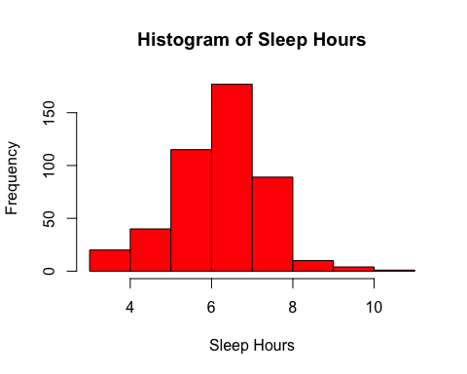

boxplot(Sleep1, main="Boxplot of Sleep Hours", ylab="Sleep Hours", col="orange")

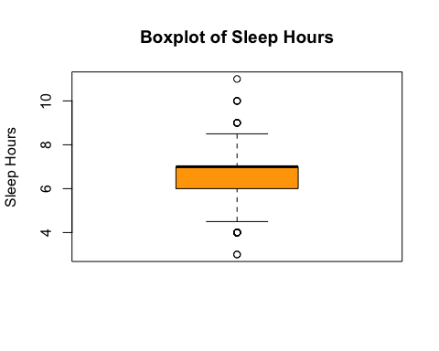

# symmetry and outliers  
summary(Sleep1)

## Min. 1st Qu. Median Mean 3rd Qu. Max. NA's   
## 3.000 6.000 7.000 6.646 7.000 11.000 1

# Part (c) - mean and median  
mean_sleep <- mean(Sleep1, na.rm = TRUE)  
median_sleep <- median(Sleep1, na.rm = TRUE)  
  
print(paste("Mean Sleep Hours:", mean_sleep))

## [1] "Mean Sleep Hours: 6.64649122807018"

print(paste("Median Sleep Hours:", median_sleep))

## [1] "Median Sleep Hours: 7"

# Notation: The mean is denoted as x̄ (x-bar).  
  
# Part (d) - Compute standard deviation and IQR  
sd_sleep <- sd(Sleep1, na.rm = TRUE)  
iqr_sleep <- IQR(Sleep1, na.rm = TRUE)  
  
print(paste("Standard Deviation:", sd_sleep))

## [1] "Standard Deviation: 1.13093794192887"

print(paste("Interquartile Range:", iqr_sleep))

## [1] "Interquartile Range: 1"

# Notation: The standard deviation is denoted as s.  
  
# Part (e) - Approximate range for 95% of sleep hours  
lower_bound <- mean_sleep - 2 * sd_sleep  
upper_bound <- mean_sleep + 2 * sd_sleep  
  
print(paste("95% of students' sleep hours fall within:", round(lower_bound, 2), "to", round(upper_bound, 2)))

## [1] "95% of students' sleep hours fall within: 4.38 to 8.91"